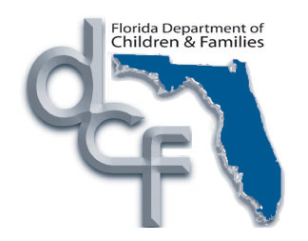

EMERGENCY SHELTER CHECKLIST

NAME:_________________________ DOB:___________________ AGE:_______

SHELTER ADMITTED TO: ___________________________________________________________

DATE OF ADMISSION: _________________

HIGH RISK _____ YES _____NO

_____ REFERRAL FORM (GENERIC)
_____ PERSONAL PROPERTY INVENTORY
_____ CONSENT FOR TREATMENT & RELEASE OF MEDICAL INFORMATION
_____ MEDICAL INFORMATION FOR LICENSED CAREGIVERS
_____ LETTER OF AUTHORIZATION TO CONSENT TO MEDICAL TREATMENT
_____ COPY OF ORDER – TRAVEL AUTHORIZATION FOR CHILDREN IN FOSTER CARE
_____ FAMILY SAFETY CONTRACT
_____ WIC LETTER
_____ LETTER OF ASSURANCE
_____ AUTHORIZATION FOR OUT OF HOME PLACEMENT
_____ INITIAL BEHAVIOR / HEALTH CHECKLIST
_____ CHILD REMOVAL SNAPSHOT

_____ SIGNED PHYSICIAN’S AFFIDAVIT - PSYCHOTROPIC MEDS (IF APPLICABLE)
_____ COPY OF SOCIAL SECURITY CARD
_____ COPY OF BIRTH CERTIFICATE
_____ COPY OF IMMUNIZATION RECORD
_____ LAST REPORT CARD
_____ MEDICAID CARD
_____ EMERGENCY SHELTER INTAKE

