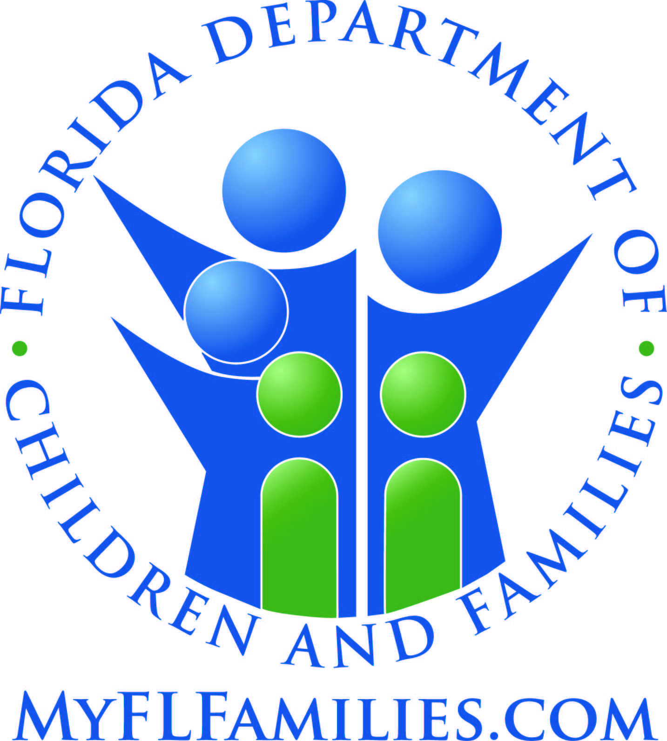

State of Florida, Department of Children and Families

REFERRAL FORM

Date: / /

Referred To: POLK COUNTY DRUG COURT Phone: 534-4612 Fax: 534-5853
Address: Bartow Courthouse, 255 N. Broadway Ave. Bartow, FL 4th floor, Red Elevators

Referral From: Title: CPI Agency: Department of Children and Families
Address:
Telephone Number:863- Fax: 863-

CLIENT AND FAMILY INFORMATION
Client’s Name: DOB: SS#:
Client’s Name: DOB: SS#:
Telephone Number: Mailing Address:

Required for all referrals to Children’s Medical Services; optional for all other referrals:
Parent’s/Guardian’s Name: Family Size: Family Income $

Reason for Referral/Notes to Referral Agency: Report #:

MONDAY – THURSDAY: 7:30 AM – 4:45 PM
FRIDAY: 7:30 AM – 3:45 PM

_________________________________is coming in for a drug screen on ________________________________.

The cost is $20. Waive Fee.

Client will have photo ID.

Please send results to .

______________________________________________________
Referring Person’s Signature Date

Response to Referral Originator:

______________________________________________________
Respondent’s Signature Date
f:\shared\casemodl\referral.doc

