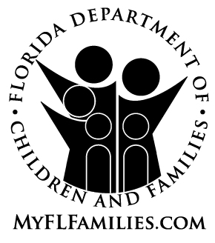
RESI

DEPATMAN POU TIMOUN AK LAFANMI NAN FLORIDA

NOTICE OF PRIVACY PRACTICES

Mwen bay mo mwen ke depatman pou timoun ak lafanmi nan Florida baze li sou CFOP 60-17, chapit 1, atachman 3 pou li ban mwen papye ki gen desizyon ki pran pou sèvi ak dosye sou sante mwen e proteje yo.

Make nonw ak lèt majiskil: ___________________________________________

SIYEN NONW: ___________________________________________

METE DAT JODI A: _______________________

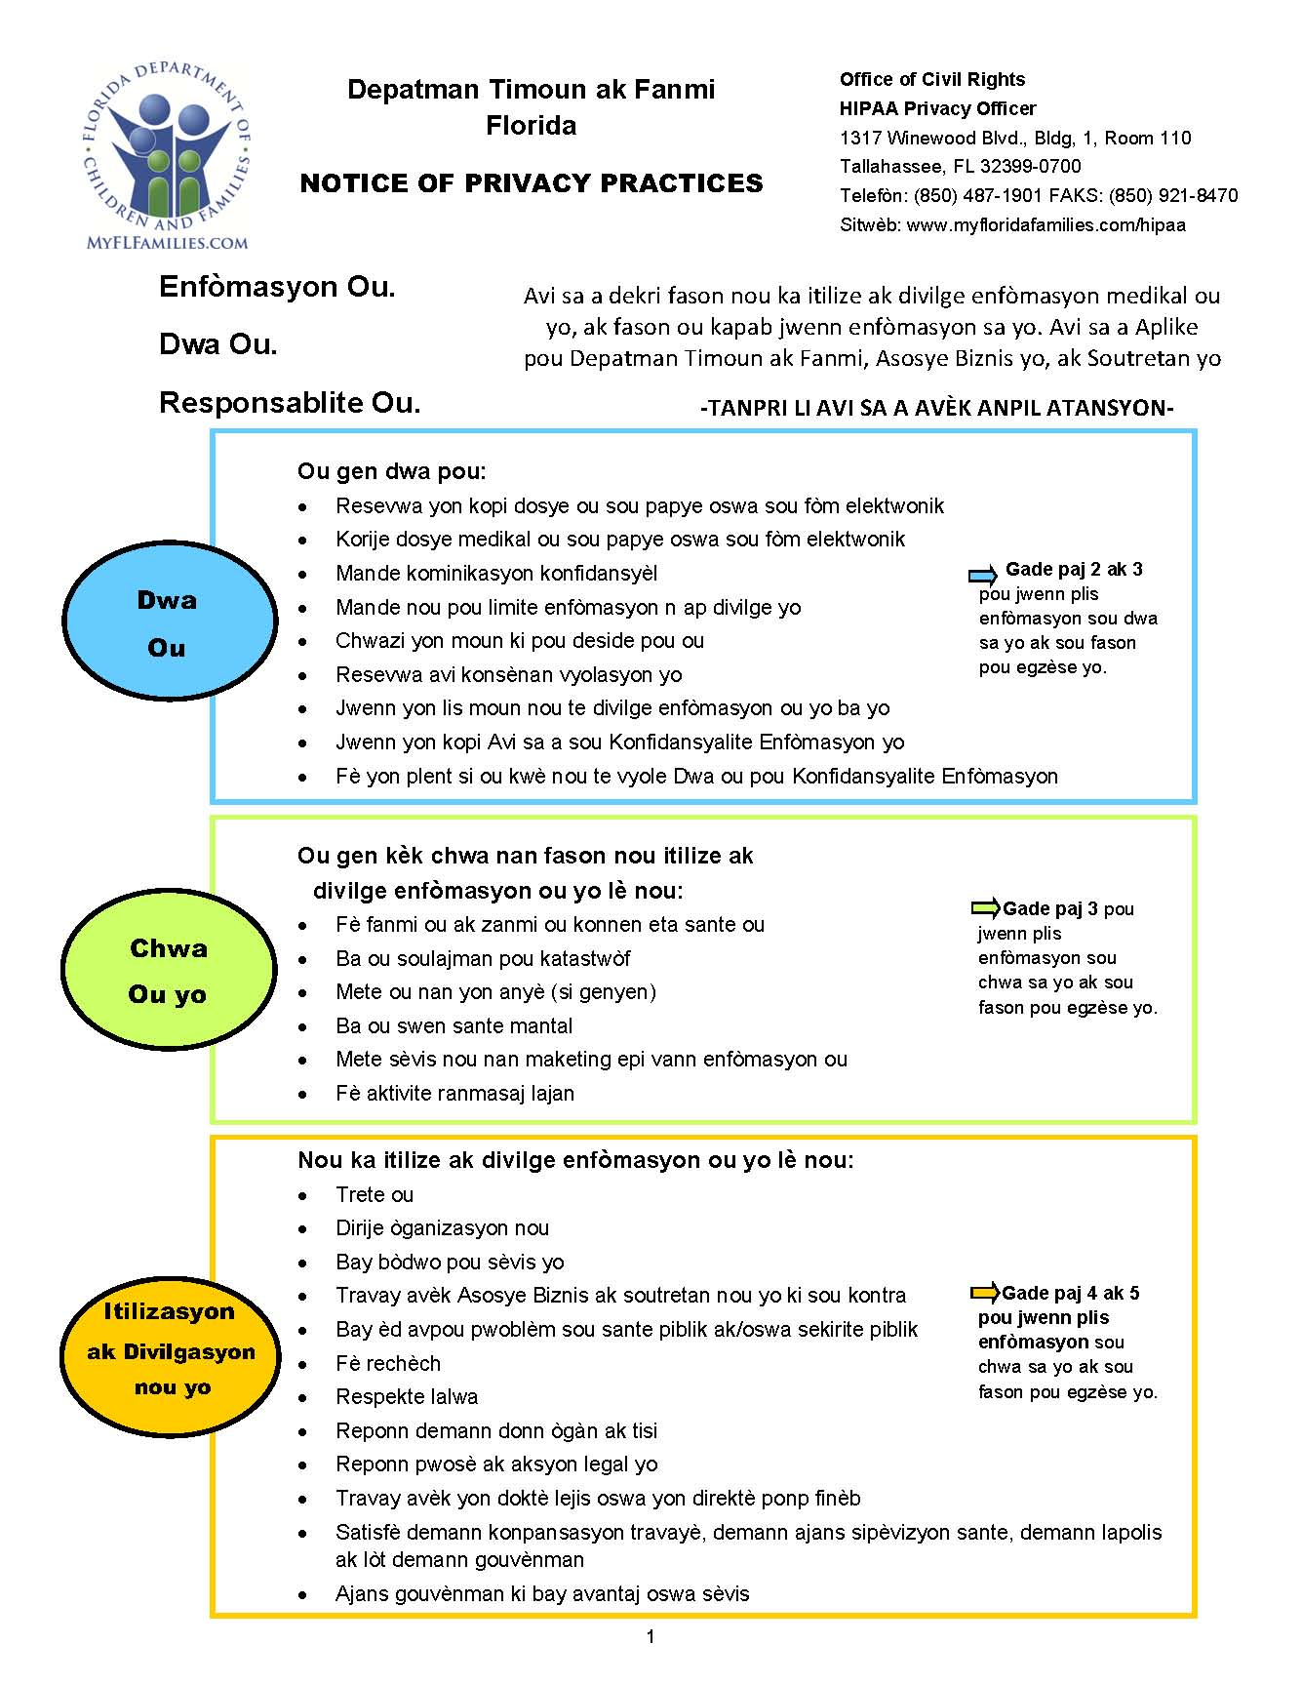

CFOP 60-17, Chapter 1, Attachment 3
