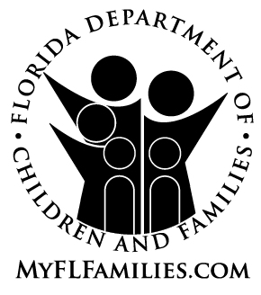
RECEIPT

FLORIDA DEPARTMENT OF CHILDREN AND FAMILIES

NOTICE OF PRIVACY PRACTICES

I hereby acknowledge receipt of the Florida Department of Children and Families CFOP 60-17, Chapter 1, Attachment 3, Notice of Privacy Practices.

Print Name: ___________________________________________

SIGNATURE: ___________________________________________

DATE: _______________________

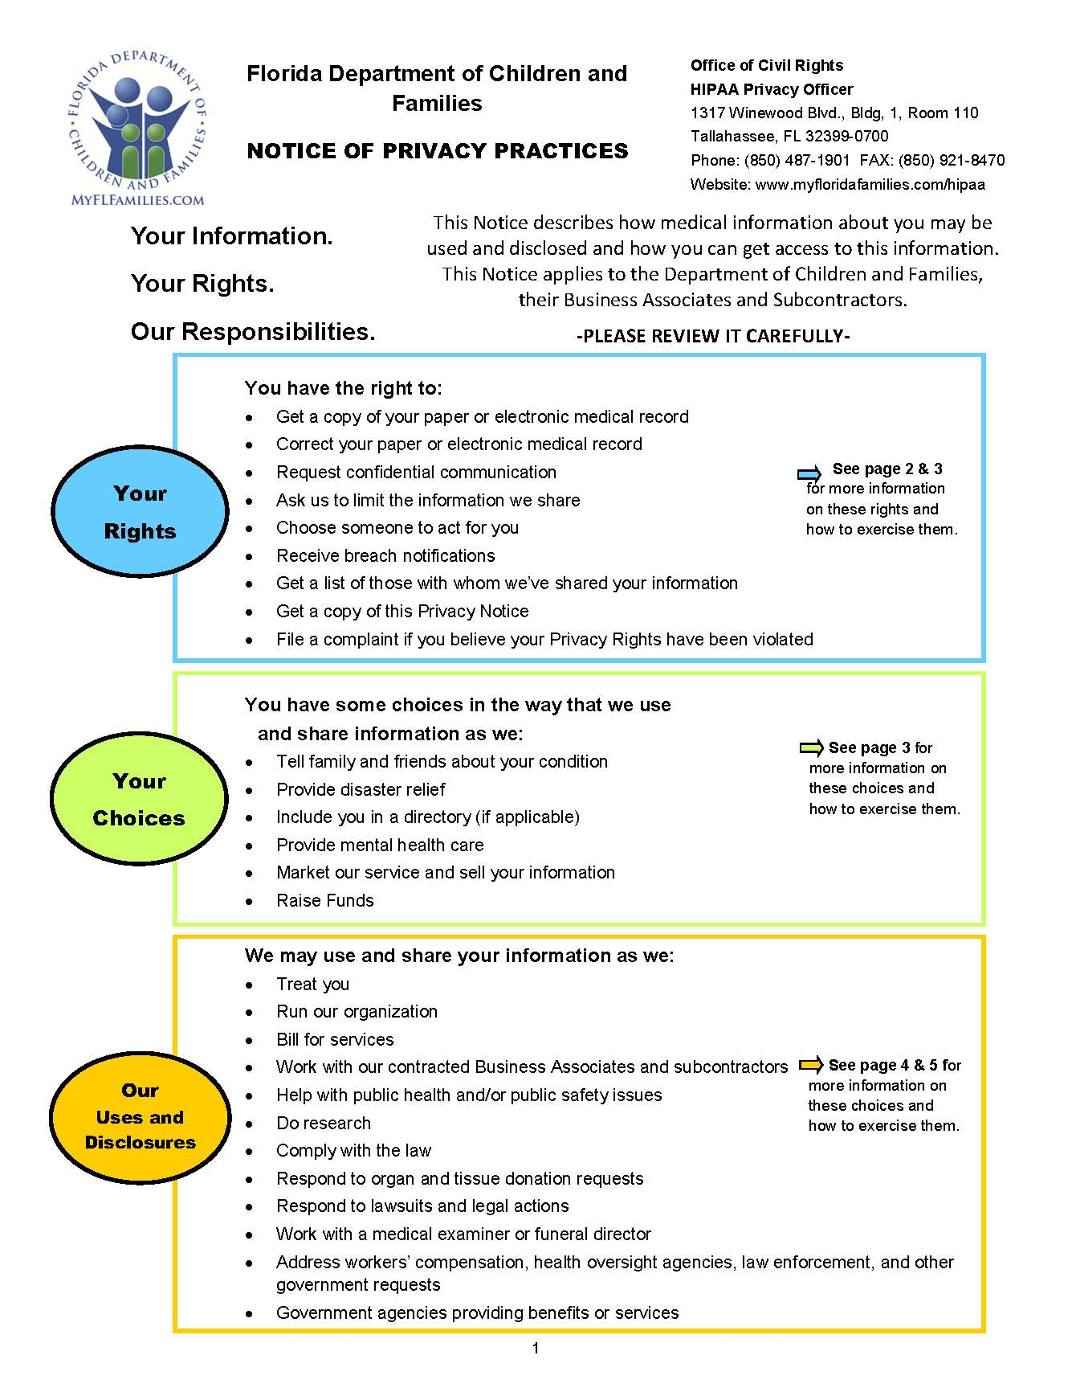

CFOP 60-17, Chapter 1, Attachment 3
